Management of Renal Abscess in 5 years old girl, A Case Report
Maryam Boroomand¹ , Mastaneh Moghtaderi², Pooya Hekmati³
1- Resident of Pediatrics, Children Medical Center, TUMS, Tehran, Iran
2- Associated Professor of Pediatric Nephrology, Chronic Kidney Disease Research Center, Children Medical Center, TUMS, Tehran, Iran, Drmoghtaderi@gmail.com, Corresponding Author,
3- Pediatric Urologyst, Pediatric Urology and Regenerative Medicine Research Center, Children Medical Center, TUMS, Tehran, Iran.
Abstract:
Renal abscesses are rare in childhood. They have vague manifestations and any delay in proper diagnosis and treatment could lead to morbidity and mortality. We present a 5 year old girl with multiple renal abscesses after pyelonephritis that lead to total nephrectomy due to multiple drug resistance.
The renal abscess may have subtle symptoms. Early diagnosis and treatment strongly prevents undue mortality and morbidity. This case highlights the need of timed diagnosis and proper treatment. There must be a clinical suspicion of renal abscess if treatments hve not enough effect on clinical condition of patient.
Key words: Acute Pyelonephritis , Renal Abscess, children
Introduction:
Renal and perirenal abscess is an uncommon potentially lethal diseases resulting from infection of the kidney or its surroundings like pyelonephritis or from hematogenous spread of another foci. [1, 2] There may be predisposing conditions like obstructive uropathy or UTI, diabetes mellitus, intravenous drugs abuse, trauma, recent abdominal or urologic operation and immunodepressivs used in malignancies or AIDS[3]. Clinical manifestations are generally nonspesific such as fever and vague abdominal pain. Elevated erythrocyte sedimentation rate (ESR) and increase of C reactive protein (CRP), leukocytosis and less often positive blood and urine cultures. Therefore delayed definite diagnosis can be quiet common. Gram-negatives mainly Escherichia coli are the most common pathogens found in cases folloining urinary tract infection. Staphylococcal renal abssess (S. aureus )are most predominate when the route of infection is haematogenous.[2] Differential diagnoses includes emphysematous pyelonephritis, papillary necrosis following acute pyeloephritis, acute malacoplakia, lobar tuberculosis, nephronia, renal cell carcinoma or Wilms’ tumour. Therefore, a full diagnostic study is rcomended[4]. Any delay diagnosis of renal abssess may lead to increase of morbidity and mortality. Nowadays it has been reduced because of the more sophisticated procedures like computed tomography (CT) scan and magnetic resonance imaging (MRI) scan[1]
Classic treatment of renal abscesses include antibiotics, surgical exploration, incision and drainage when it is nessessary, or nephrectomy as the last one. Small renal abscesses can be treated efficiently with the propare drainage and a full course of intravenous antibiotics[1]
We describe a case of multiple renal abcessess following pyelonephritis that eventually lead to total nephrectomy because of microbial drug resistance.
Case Presentation:
A 5 years old girl was reffered to our hospital with abdominal pain and fever from 3 days ago .The pain was periumblical, contineus radiating to left flank. Other symptoms were malaise, anorexia, vomiting, fever and dysuria .She reported long period of constipation and voiding dysfunction lasting several months ago. She did not have history of any urinary tract infection in the past. In physical examination she had left costovertebral angle tenderness , fever and a dimple in upper anal verge. She had received cefexime before admitting in hospital.
Lablatory findings include lukocytosis (25000) with neutrophill predominance, ESR=97, CRP=31, active urine analysis with negative urine and blood culture. Serum immunoglobulin levels were within normal range, immunodeficiency disorders including late-onset common variable immunodeficiency were unlikely. The biochemistry study was normal. First performed sonography was normal .Cefteriaxon was started at first but as the fever continued beyond 3 dayes amikacine was added. The fevere continued for 7dayes , unilatral lymphadenopathy and lukocytosis appeared , ESR raised more, so reumatologic consultation was reuested because of suspicion of Kawasaki disease and IVIG and asprine was started. Echocardioghraphy was normal. But the fever did not improved, so renal sonography was repeated that revealed three hypoechoic lesions without vascularity: in the upper pole of the left kidney (38×25 mm), lower pole of left kidney (24×10 mm) and subcortical middile lobe of left kidney(9×7 mm) with perinephric liquid accumulation. DMSA scan was showon multiple defects in left kidney. CT angiography of left kidney revealed enlargment and heterogenosity of kidney, fat stranding and inflammation in perinephric area, several lesions withlow attenuated in upper pole(44×30 mm) and lower pole (16×9 mm), and also three paraaortic lymphnodes in left renal hilum(6×9 mm). In VCUG she had grade 3 reflax in left kidney and widening of left pyelocalicial system due to abscess formation .As a result ceftriaxon was discontinued, meropenem and vancomycin were added to amikacin. But because of no response to medical treatment after urologic consultation nephrectomy was performed. After 6 months fallow up BUN, Cr, electrolytes are normal. Constipation and voiding dysfunction improved remarkably.
DISCUTION
Renal abscesses occur in all ages and are three times more common in males than in females. These abscesses are walled-off cavities and most of them are unilateral single lesions (77%) and occur in the right kidney more frequently(63%). The incidence of renal abscess in children is unknown. (4) Interestingly our patient was female with multiple renal abscesses in her left kidney. Diagnosis of renal abscess is a clinical challenge due to diversity of the source of infection and different pathogenetic mechanisms, such as complication of UTI, hematogenous spread of a far infectious foci, or in rare cases of staphylococcal carbuncle proximal kidneys (5,6). Our case had pyuria with negative urine and blood culture. The clinical diagnosis of renal or perinephric abscess should be suspected in a patient with inconsistent signs and symptoms, including prolonged fever and flank pain, and laboratory evidence of chronic inflammation such as elevated ESR and CRP. Detection on of renal abscess on imagings ideally computed tomography confirms the diagnosis(7). Our patient had prolong fever, luckocytosis with neutrophyllia and elevated ESR, CRP and normal sonoghraphy at first. In most of children, the pathogenesis may be associated with an ascending infection superimposed on a pre-existing malformation of urinary truct, particularly vesicoureteral reflux (VUR).(8) She had left VUR (grade 3) but didn’t have any history of previous urinary tract infection. Classical treatment of renal abscesses is surgical exploration, incision and drainage, or nephrectomy. In fact, simple invasive treatment appeared in early 1970s, is replaced with more conservative treatments due to the progress in imaging techniques to detect te abscess and also emergence new antibiotics. Small renal abscesses can be effectively treated with the complete drainage and a full course of intravenous antibiotics. (9) Large size of abscess, presence of obstructive uropathy, severe vesicoureteral reflux, diabetes, old age, and gas forming organisms are the major factors associated with treatment failure. If there is a large abscess or obstructive uropathy, and no clinical improvement occurs after 48 to 72 hours of appropriate antibiotic thearapy nephrostomy should be considered. (1). Our patient received proper antibiotic for about 3 weeks with no improvement, so eventually radical nephrectomy was done. After 6 months fallowup she has naormal blood pressure and renal function test.

Conclusion:
The diagnosis of renal abscess is frequently delayed, and the mortality and morbidity is extensive in most cases. Thus, proper diagnose and treatment is necessary. renal abscesses should be seriously considered when a patient presents with symptoms of pyelonephritis but and did not response to standard treatments. Sometimes renal abscess that cannot be treated with roper medical treatments lead to partial or even total nephrectomy.

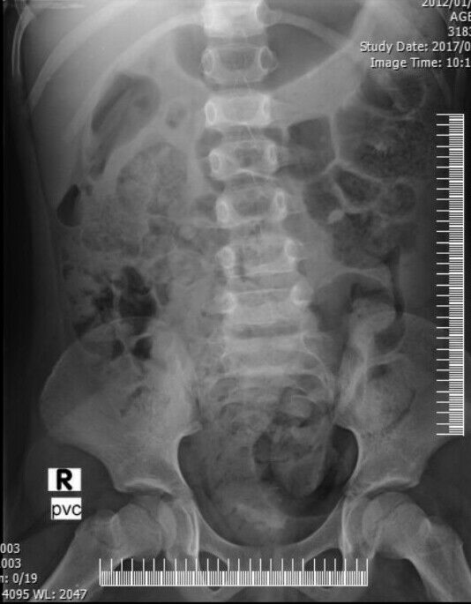
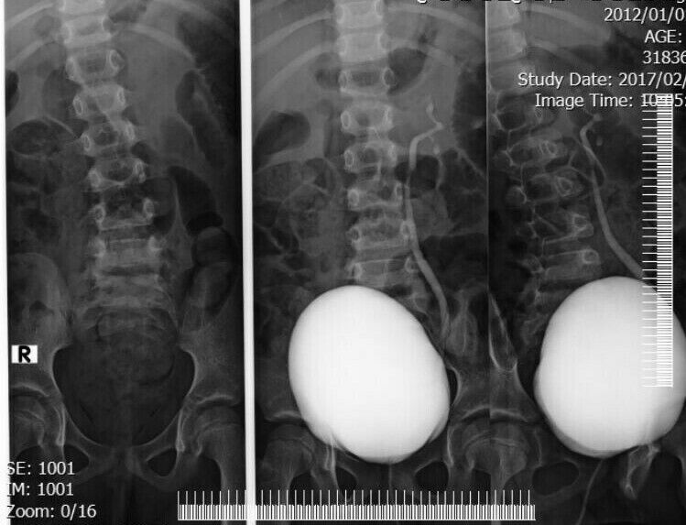
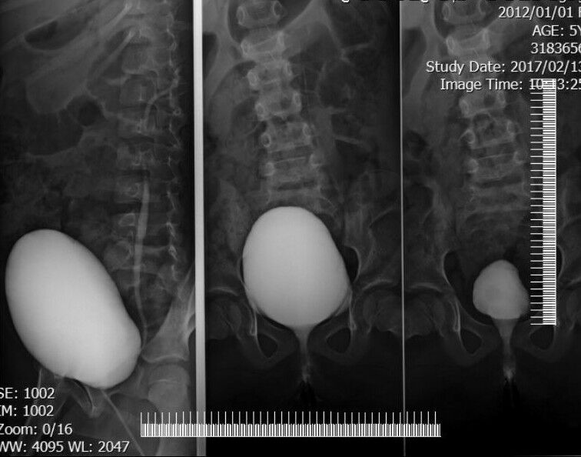

References:
1.Lyh-Jyh Hao, Ray-Shyang Wang, et al.Proper diagnosis and treatment of renal abscess.International Journal of Case Reports and Images, 2014 December;Vol. 5 No. 12.
2.Candida Cancelinha, Lea Santos, Carmen Ferreira, Clara Gomes.Renal abscesses in childhood: report of two uncommon cases.BMJ Case Rep 2014.
3.Regina Célia de Souza Campos Fernandes & Príscila Diane Assed Caires Duarte.Perinephric and renal abscesses in children.Rev. Inst. Med. trop. S. Paulo,2002 ;44(6):341-344.
4.Secil Conkar, Ipek Kaplan Bulut, Sevgi Mir .Renal abscess in a previously healthy 4-year-old girl.Ped Urol Case Rep 2016;3(5):170-175 .
5. Angel C, Shu T, Green J, Orihuela E, Rodriguez G, Hendrick E. Renal and perirenal abscess in children: proposed physiopathologic mechanisms and treatment algorithm. Pediatr Surg Int. 2003;1981-29:35–9.
6.Fernandes RC, Duarte PD. Perinephric and renal abscesses in children: a study of
three cases. Rev Inst Med Trop S Paulo. 2002;44(6):341–4.
7.Shimizu M, Katayama K, Kato E, Miyayama S, Sugata T, Ohta K. Evolution of acute focal bacterial nephritis into a renal abscess. Pediatr Nephrol. 2005;20(1):93-5.
8. Chaudhry S, Bolt R. Bilateral renal abscess in a previously healthy 11-yearold girl. Eur J Pediatr. 2010;169(11):1423-5.

9. Lee SH, Jung HJ, Mah SY, Chung BH. Renal abscesses measuring 5 cm or less: outcome of medical treatment
without therapeutic drainage. Yonsei Med J 2010 Jul;51(4):569–73.

