**Familial hypercholesterolemia: a case report**

Sima Rafieyian MD

Shahla Roodpeyma MD

Reza Shakeri MD

Department of pediatric cardiology, Shahid Modarres Hospital,

Shahid Beheshti University of Medical Sciences, Tehran, Iran

Corresponding Author:

Dr Shahla Roodpeyma, Pediatric Cardiology Ward, Shahid Modarres Hospital, Saadat Abad, Tehran 1998734383, Iran

Tel: 0098 21 22074087-98

Fax: 0098 21 22074101

Mail: [roodpeyma_shahla@yahoo.com](mailto:roodpeyma_shahla@yahoo.com)

**Abstract**

Familial hypercholesterolemia (FH) is a hereditary dislipidemia. Patients present with extremely high level of low-density lipoprotein cholesterol (LDL-C), which is due to mutation in the gene of LDL receptor. Homozygous patients (HoFH) whose incidence is 1 in 1.000.000 are at high risk of premature aortic valve stenosis, and coronary artery atherosclerosis. In homozygous individuals cardiovascular complications can occur in childhood. The current study presented a 12-y-old boy with HoFH who suffered from mild aortic stenosis, and right coronary artery atherosclerosis. The patient underwent a successful coronary artery stenting, and was discharged with pharmacologic therapy.

**Key Words**

Cardiovascular disease, Familial hypercholesterolemia, Homozygous form.

**Introduction**

Familial hypercholesterolemia (FH) is a severe autosomal dominant disease. Patients with FH suffer from significant increase in low density lipoproteins (LDL-c) level. In some populations, the heterozygous form is as common as 1 in 300. The heterozygous situation is generally expressed in the pediatric age group and it is characterized by total and LDL-c levels of approximately 300 and 240 mg/dL respectively. Children and adolescents with the homozygous form of FH (HoFH) have total and LDL cholesterol in the range of 600 to 1.000 mg/dL and 450 to 850 mg/dL respectively (1). Homozygous form is very rare and affects 1 in 1.000.000 people in the world. European Society of Atherosclerosis suggested that the incidence of HoFH is 1 in 160 000 to 300 000 people (2). The disorder is characterized by severe and intractable hypercholesterolemia due to deficiency of functional LDL receptor or its ligand or processing proteins (3). Homozygous patients suffer from multiple xanthomas, and are at high risk for premature cardiovascular atherosclerosis in coronary arteries, aorta, and carotid arteries. Homozygous patients develop skin lesion as xanthoma by the age of 5 years and develop coronary artery disease between the ages of 10 and 20 years. These patients often develop aortic stenosis.

The aim of this article is to introduce a 12- years old Iranian boy with HoFH which presented with multiple xanthoma and severe cardiovascular complications.

**Case presentation**

A 12-y-old boy with heart murmur was admitted for evaluation of cardiovascular disorders.Inphysical examination the general condition wasgood, the patient was acyanotic, well developed, and well nourished. Thrill was palpable at supra sternal notch. A grade 4/6 ejection systolic murmur was audible at upper right sternal border, and pulses were normal. There was multiple large xanthoma with diameter of 3 to 4 centimeter at the extensor surface of both elbows, both knees, and at the buttocks (Figure 1, Figure 2). The rest of physical examination was unremarkable. The Parents are first degree cousins; and are known cases of heterozygous hypercholesterolemia. The older brother of patient had died at 24 years of age due to sudden cardiac death. Laboratory tests including CBC, electrolytes, and liver function tests were normal. Chest X ray was normal. ECG showed normal sinus rhythm, left axis, and LVH. Echocardiography showed mild aortic stenosis with 37 mm Hg pressure gradient between left ventricle and aorta, and other findings were normal. The results of lipid profile of patient are shown in Table 1. The physical examination and lipid profile were compatible with diagnosis of HoFH. Cardiac catheterization including coronary angiography was conducted; and showed mild aortic stenosis, two significant stenoses at right coronary artery, and 3 points of irregularity at left coronary artery. The patient underwent percutaneous coronary intervention, and stenoses of right coronay artery were relieved by stent implantation (Figure 3, Figure 4). Pharmacologic treatment with vastatin and cholesteramine was started. One month after treatment, there was no significant decline in LDL-c. Treatment with lipid apheresis was recommended to parents, but they did not give consent to this therapy. The patient is under pharmacologic therapy and close follow-up.

**Discussion**

There are regional differences in the clinical, phenotype, and biochemical characteristics of FH (4, 5). The report of seven-year follow-up of a Chinese child with HoFH showed that vascular involvement of heart gradually progressed to multivessels atheromathous plaque formation, cardiac dilatation due to severe mitral regurgitation, and severe stenosis of coronary arteries. The study also showed combined therapy of atrovastatin, ezetimibe,and probucol could not keep the LDL-c level below the target value, and could not prevent progressive cardiovascular disease throughout the study period (6). Zhao x et al reported a 17-year-old women with history of hypercholesterolemia since she was 2 years old. Angiocardiography showed triple vessel lesion and coarctation of aorta (7). Our patient developed aortic valve stenosis and coronary arteries involvement early in childhood and drug therapy was not able to reduce the LDL-c to desirable level. Patients with HoFH are at extremely high risk for early myocardial infarction, which has been documented as early as 2 years of age and require very aggressive therapy. CT angiography is helpful for surveillance of the coronary atherosclerosis (8). Kaylkcloglu M, et al reported 17 (11 female, 6 male) HoFH Turkish patients between the years 2000-2013. Parents of 65% of patients had consanguineous marriage. The frequencies of presentations were as follow: xanthoma 59%, aortic valve pathology 59%, and coronary artery disease 59%, and carotid artery plaques 47%. They concluded that progressive atherosclerosis and aortic stenosis are due to delayed treatment with lipid apheresis (9).Parents of our case had consanguineous marriage and xanthoma was early clinical presentation followed by cardiovascular complications.

Pharmacologic reduction of LDL-c by using statin drugs is essential therapy for reducing the risk of cardiovascular disease. Bile acid sequestrants including cholesteramine or colestipol are usually prescribed in combination with statin. Ezetimibe reduces plasma LDL-c by blocking sterol absorption in enterocytes. There are not enough experiments with cholesterol- absorption inhibitors in children. The recent advents of new class of lipid-lowering agents provide new hope. These compounds including mipomersin, and lomitapid act by inhibiting apolipoprotein B synthesis. Apolipoprotein B is endogenous and its source is liver and genetic factors influence its level. The level of apolipoprotein B was very high in our patient. Monoclonal antibodies act by enhancing LDL catabolism. Lipoprotein apheresis is an effective treatment for patients with severe hypercholesterolemia who are resistant to the standard therapy. Lipoprotein apheresis is an exteracorporeal elimination technique, which specifically remove LDL-c from circulation. At present lipoprotein apheresis combined with high-dose statin and ezetimibe is the best available therapy for homozygous patients, and statin-refractory heterozygous individuals (10). Patients with HoFH do not respond to conventional antilipid therapy including statins; due to defective LDL receptors, therefore LDL apheresis is treatment of choice. However in order to prevent both the development of cardiovascular events and aortic stenosis, regular apheresis should be initiated before the age of 10 years (11). We could not try this treatment in our patient.

**Conclusion**

Children with skin xanthoma should be carefully evaluated for cardiovascular diseases. Appropriate intervention combined with drug therapy can reduce their ailments.

Table 1: Lipid profile before and after pharmacologic therapy

|  |  |  |  |  |  |  |
| --- | --- | --- | --- | --- | --- | --- |
| **Date** | **Triglyceride**  **Mg/dL** | **Total cholesterol**  **Mg/dL** | **LDL-c**  **Mg/dL** | **HDL-c**  **Mg/dL** | **VLDL-c**  **Mg/dL** | **Atherogenic factor**  **LDL: HDL** |
| 2015, Aug,13 | 151 | 1121 | 758 | 22 | 341 | 34.5 |
| 2015,Sep,19 | 82 | 749 | 654 | 22 | 73 | 29.7 |
| 2015,Nov,25 | 96 | 654 | 550 | 70 | _ | _ |

Apolipoprotein A-1= 61 mg/dL (normal= 104-202)

Apolipoprotein B-100= 401 mg/dL (normal= 60-133)

Lipoprotein a=122.8 mmol/L (cut off value for normal level < 75)

**References**

1. Daniel SR. Coronary risk factors in children. Moss and Adams’ heart disease in infants, children, and adolescents including the fetus and young adult. Allen HD, Driscoll DJ, Shaddy RE, Feltes TF. Eight Edition. Lippincott, Williams & Wilkins. Philadelphia 2013:1514-1548.
2. Cuchel M, Bruckert E, Ginsberg HN. Homozygous familial hypercholesterolemia: new insight and guidance for clinicians to improve detection and clinical management (A position paper from the consensus panel on familial hypercholesterolemia of the European Atherosclerosis Society): Eur Heart J 2014; 35: 2146-57.
3. Liyanage KE, Burmet JR, Hooper AJ, van Bocloxmeer FM. Familial hypercholesterolemia: epidemiology, Neolithic origins and modern geographic distribution. Crit Rev Clin Lab Sci 2011; 48:1-18.
4. Pimstone SN, Sun X-M, du Souitch C, et al. Phenotypic variation in heterozygous familial hypercholesterolemia: a comparison of Chinese patients with the same or similar mutations in the LDL receptor gene in China or Canada. Arterioscler Thrombo Vasc Biol 1998; 18:309-15.
5. Hu M, Lan W, Lam CW, et al. Heterozygous familial hypercholesterolemia in Hong Kong Chinese. Study of 252 cases. Int J Cardiol 2013; 16:762-7.
6. Jiang L, Gao F, Hu L-B, et al. Seven-year clinical follow-up of a Chinese homozygous familial hypercholesterolemia child with premature xanthomas and coronary artery disease- A need for early diagnosis and aggressive treatment. International Journal of Cardiology 2014, 177: 188-191.
7. Zhao X, Bu L, Qin S, et al. Early development of xanthoma and coronary disease in young female with homozygous familial hypercholesterolemia. International Journal of Cardiology 2014; 176: e15-e19.
8. De Ferranti SD. Familial hypercholesterolemia in children and adolescents: A clinical perspective. Journal of Clinical Lipidology 2015; 9: 511-519.
9. Kaylkcloglu M, Klsmal E, Can L, Payzin S. Long –term follow-up in patients with homozygous familial hypercholesterolemia; 13-year experience of a university hospital lipid clinic. Turk Kardiyol Dern Ars 2014; 42(7): 599-611.
10. Blaha V, Blaha M, Lanska M, et al. Position of lipoprotein apheresis in present. Vnitr Lek 2015; 61 (11): 958-964.
11. Kaylkcloglu M. Homozygous familial hypercholesterolemia. Turk Kardiyol Dern Ars; 2014 Oct; 42 suppl 2: 19-31.

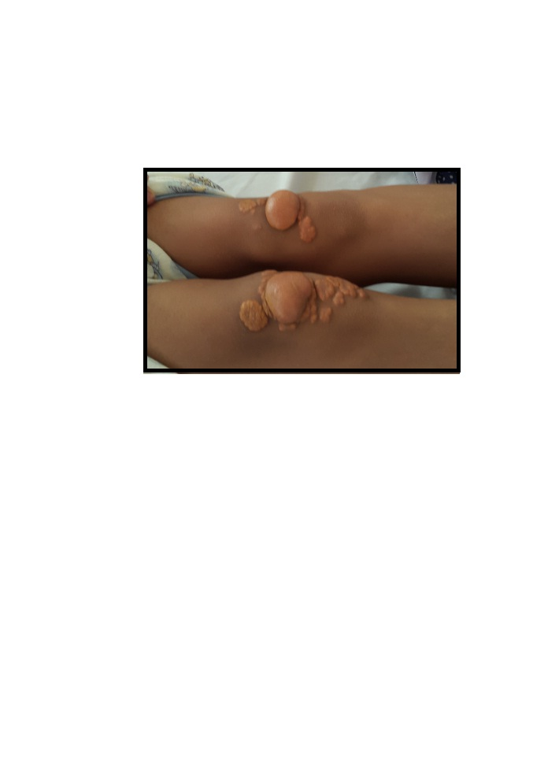

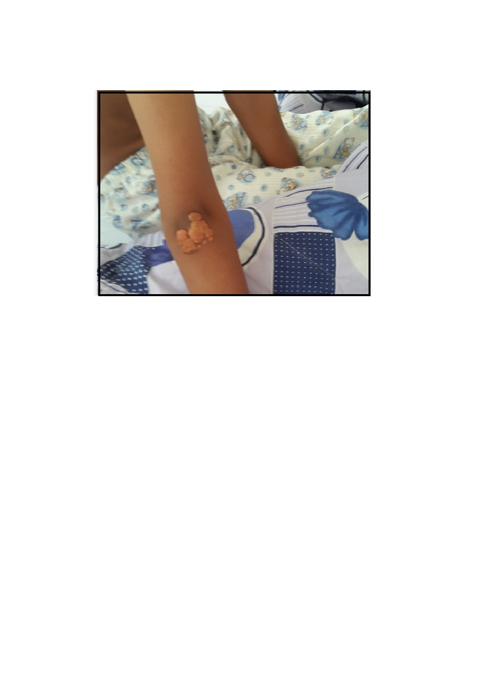

D:\My Document\Articles in journals\Hyperchlosterolemia familial\Hypercholestermia familial\pre stent.tif

D:\My Document\Articles in journals\Hyperchlosterolemia familial\Hypercholestermia familial\post stent.tif

**Figures legend**

Figure 1: Xanthoma lesion at extensor surface of knees.

Figure 2: Xanthoma lesion at extensor surface of elbows.

Figure 3: Two points of stenosis at right coronary artery.

Figure 4: Stent implantation revealed stenosis of right coronary artery.

Figure 1 is presented in page 10

Figure 2 is presented in page 11

Figure 3 is presented in page 12

Figure 4 is presented in page 13